Scholarship Application  2016 Summer Camp | 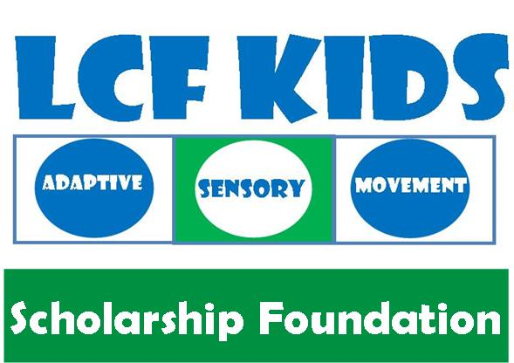

Thank you for applying for LCF Kids Scholarship. This scholarship is intended to help those families who are not able to afford our services. LCF Kids will award scholarships to children with disability that has a need to improve their gross motor skills, sport skills, athletic development and social skills. Please complete the application form and submit to info@lcfkids.com

Applicant Information
Child’s Name
Date of Birth
Street Address
City ST ZIP Code
Parent’s Name
Home Phone
Work Phone
E-Mail Address

Are you a current client of LCF KIDS?

___ Yes | ___No

Referred by:
____LCF Kids ____Autism Association ____Down syndrome Association ___Other ____________

Summer Camp: Place 1, 2, 3 in space below to prioritize week of preference)
____ Jun 20th – 24th AM ____ Jun 20th – 24th PM ____ Jun 27th – Jul 1st AM ____ Jun 27th – Jul 1st PM

____ Jul 5th – 8th AM ____ July 11th – 15th AM ____ July 18th – 22nd AM ____ July 25th – 29th AM

____ July 5th – 8th PM ____ July 11th – 15th PM ____ July 18^{h} – 22nd PM ____ July 25th – 29th PM

What challenges does your child have?
___ Gross Motor ___ Social Skills ___ Coordination ___ Balancing ___ Sport Skills

___ Strength/ Cardio Vascular Endurance ____ Visual Spatial Awareness

___ Behavioral Problems If so, please explain ______________________________________________

Household Income

Average household income:
- ____ Less than $25,000
- ____ $25,000 to $34,999
- ____ $35,000 to $49,999
- ____ $50,000 to $74,999
- ____ $75,000 to $99,999
- ____ $100,000 to $149,999
- ____ $150,000 or more

Why does your child deserve this scholarship?

Briefly describe why your child deserves this scholarship, use additional paper if necessary.

Any Additional Information we should know?

Please state any additional information you think we should know that may help your child in this award.

Person to Notify in Case of Emergency
Name
Street Address
City ST ZIP Code
Home Phone
Work Phone
E-Mail Address

Agreement and Signature

By submitting this application, I affirm that the facts set forth in it are true and complete. I understand that if I am awarded this scholarship, any false statements, omissions, or other misrepresentations made by me on this application may result in my immediate withdrawal from LCF Kids
Name (printed)
Signature
Date

